**Usage of MessageForm**

Below are several examples of using Message and MessageForm classes. (More examples you can find in Test project within MessageForm solution.) The respective code follows the image.

**Using Message Class**

Message box with OK button (XP and Vista style):

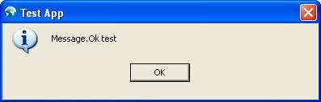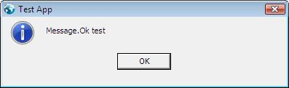

http://www.codeproject.com/images/minus.gifCollapsehttp://www.codeproject.com/images/copy_16.png [Copy Code](http://www.codeproject.com/KB/dialog/AdvancedMessageBox.aspx)

Cliver.Message.Inform("Message.Ok test");

Message box with 2 custom buttons (XP and Vista style):

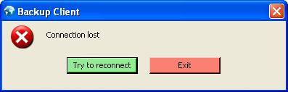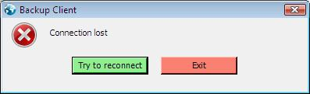

http://www.codeproject.com/images/minus.gifCollapsehttp://www.codeproject.com/images/copy_16.png [Copy Code](http://www.codeproject.com/KB/dialog/AdvancedMessageBox.aspx)

*//returns clicked button index*

int a = Cliver.Message.Show(SystemIcons.Error, "Connection lost", 0,

"Try to reconnect", "Exit");

Message box with 3 custom buttons and checkbox:

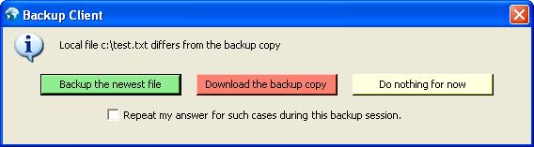

http://www.codeproject.com/images/minus.gifCollapsehttp://www.codeproject.com/images/copy_16.png [Copy Code](http://www.codeproject.com/KB/dialog/AdvancedMessageBox.aspx)

*//Set message box caption once and forever*

Cliver.Message.Caption = "Backup Application";

*//returned silent box state*

bool r;

*//returned clicked button index*

int a;

*//show message box with 3 buttons*

a = Cliver.Message.Show(SystemIcons.Information, out r,

@"Local file c:\test.txt differs from the backup copy", 0,

"Backup the newest file",

"Download the backup copy",

"Do nothing for now"

);

What if message box has to display unpredictably long text, for instance, an error stack? Sometimes the message can be so long that a .NET MessageBox will go out of the screen making the end of the message invisible. Here is an example how MessageForm treats such 'unsafe' cases:

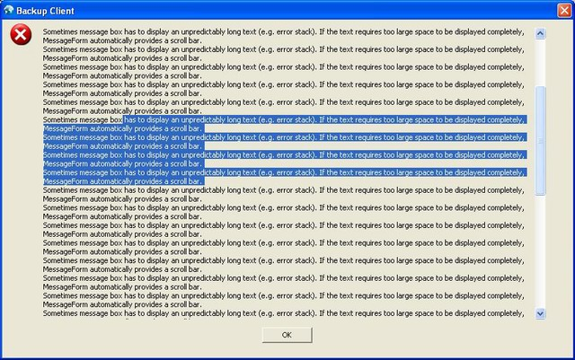

**Using MessageForm Directly**

Message box with 6 buttons, checkbox and custom message icon. Notice that MessageForm can accept Image type in place of Icon type.

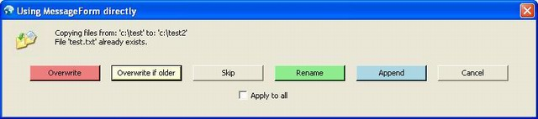

How it looks in the classic style on screen with less resolution:

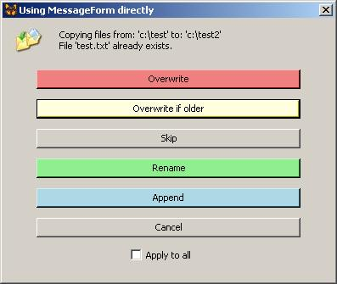

http://www.codeproject.com/images/minus.gifCollapsehttp://www.codeproject.com/images/copy_16.png [Copy Code](http://www.codeproject.com/KB/dialog/AdvancedMessageBox.aspx)

Cliver.MessageForm mf = new MessageForm(

"Using MessageForm directly",*//caption*

*//message*

"Copying files from: 'c:\\test' to: 'c:\\test2'\nFile 'test.txt' already exists.",

new Color[6] {

Color.LightCoral,

Color.LightYellow,

Color.Empty,

Color.LightGreen,

Color.LightBlue,

Color.Empty,

},*//button colors*

new string[6] {

"Overwrite",

"Overwrite if older",

"Skip",

"Rename",

"Append",

"Cancel"

},*//array of answers*

1,*//default button*

"Apply to all",*//silent box text*

new Bitmap("../../copying.jpg")*//message icon, can be set from image*

);

*//set icon in the capture*

mf.Icon = new Icon("../../computers308.ico");

*//show message form*

mf.GetAnswer();

*//get state of silent checkbox*

bool silent = mf.Silent;